**Play Hierarchical Clustering**

**R Studio Output: -**

**Cluster Dendogram: -**

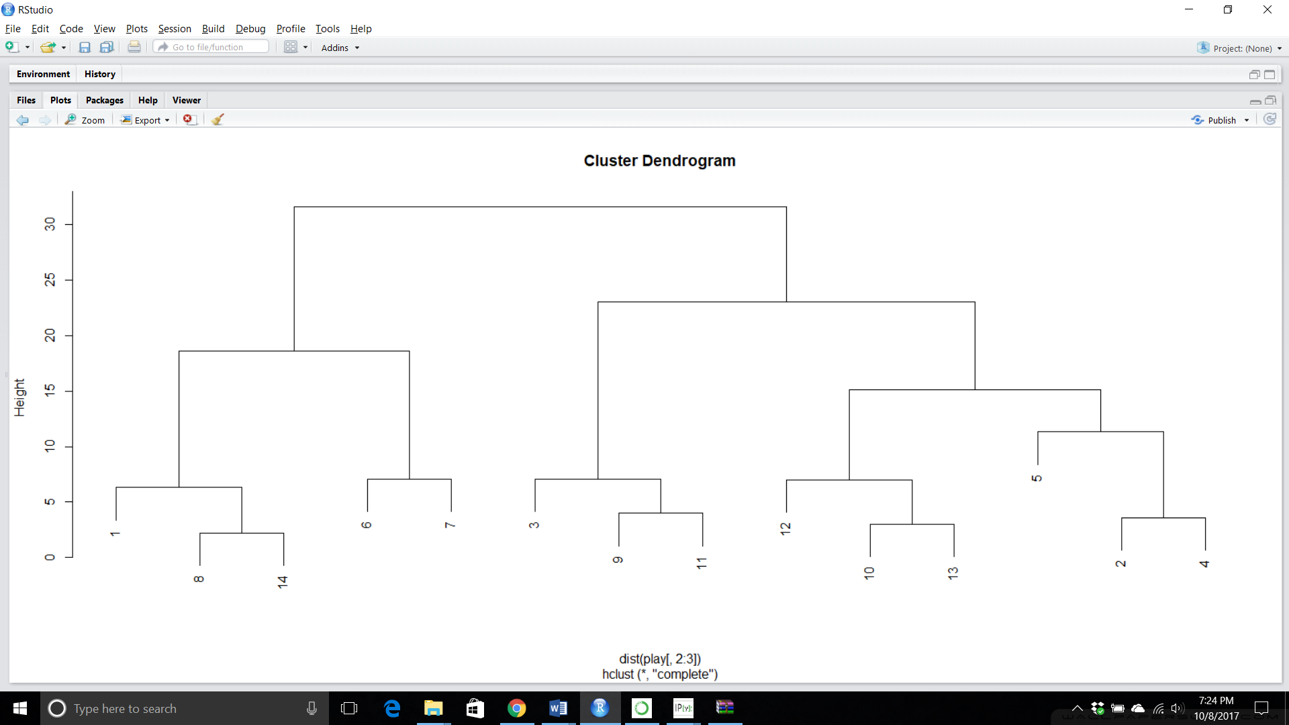

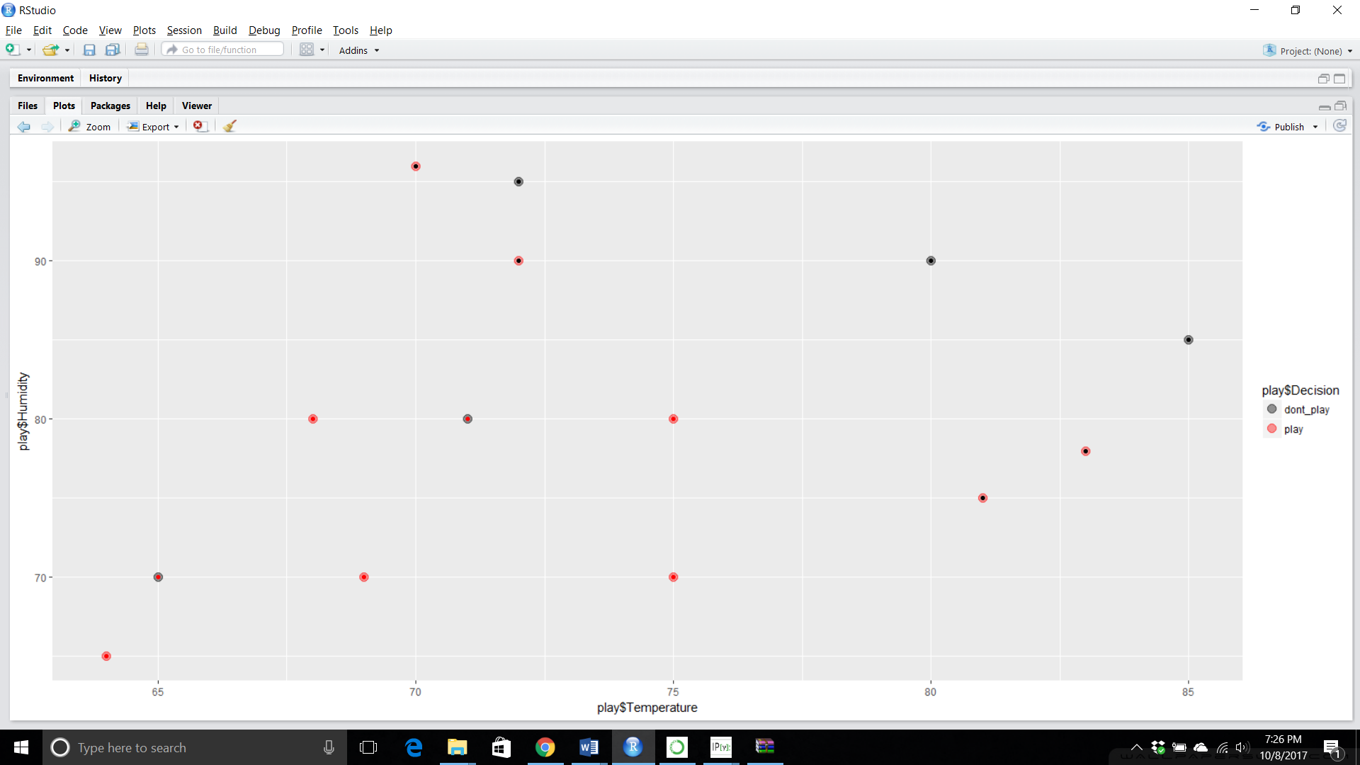

**Orange Output: -**

**Data table in Orange: -**

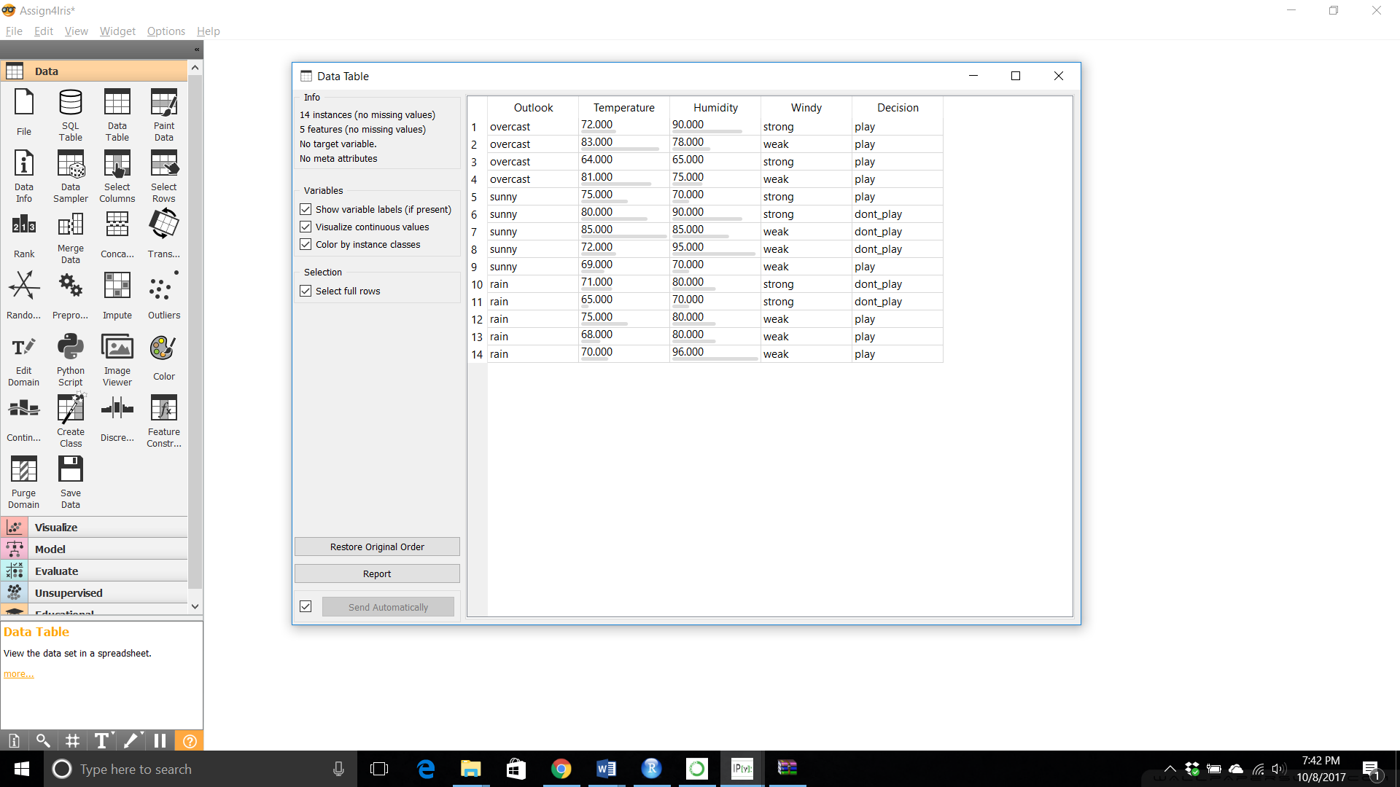

**Scatter Plot**

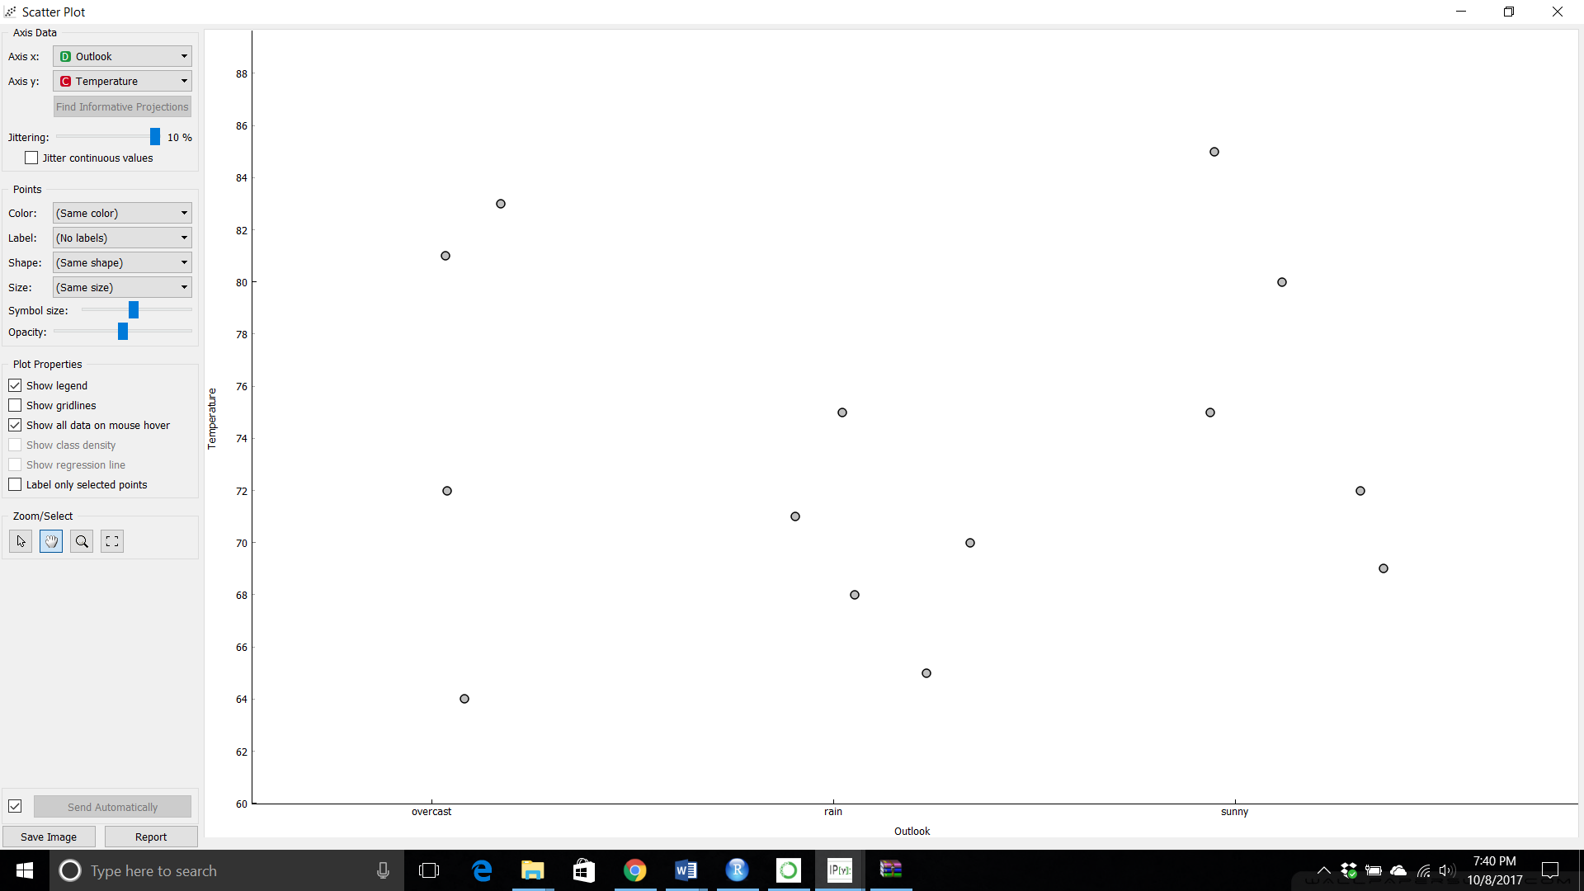

**Distribution Plot: -**

